**Problem Solving:**

#1

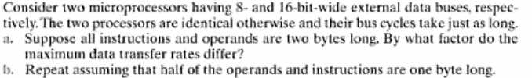

**Solution:**

**a.** During a single bus cycle, the 8-bit microprocessor transfers one byte while the 16-bit microprocessor transfers two bytes. The 16-bit microprocessor has twice the data transfer rate.

b. Suppose we do 100 transfers of operands and instructions, of which 50 are one byte long and 50 are two bytes long. The 8-bit microprocessor takes 50 + (2 x 50) = 150 bus cycles for the transfer. The 16-bit microprocessor requires 50 + 50 = 100 bus cycles. Thus, the data transfer rates differ by a factor of 1.5.

#2

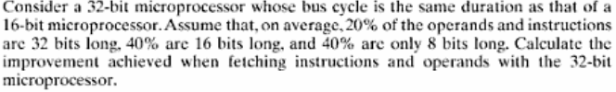

**Solution:**

Consider a mix of 100 instructions and operands. On average, they consist of 20 32-bit items, 40 16-bit items, and 40 bytes. The number of bus cycles required for the 16-bit microprocessor is (2 × 20) + 40 + 40 = 120. For the 32-bit microprocessor, the number required is 100. This amounts to an improvement of [(120-100)/120]*100% or about 17%.

**#3**

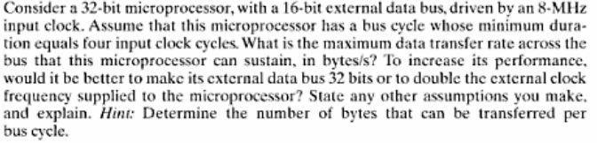

**Solutions:**

Clock cycle = 

Bus cycle = 4 ×125 ns = 500 ns

2 bytes transferred every 500 ns; thus transfer rate = 4 MBytes/sec

Doubling the frequency may mean adopting a new chip manufacturing technology (assuming each instructions will have the same number of clock cycles); doubling the external data bus means wider (maybe newer) on-chip data bus drivers/latches and modifications to the bus control logic. In the first case, the speed of the memory chips will also need to double (roughly) not to slow down the microprocessor; in the second case, the "wordlength" of the memory will have to double to be able to send/receive 32-bit quantities.

**Example 4.1** Refer to text book

Suppose that the processor has access to two levels of memory. Level 1 contains 1000 words and has an access time of 0.01 s; level 2 contains 100,000 words and has an access time of 0.1 s. Assume that if a word to be accessed is in level 1, then the processor accesses it directly. If it is in level 2, then the word is first transferred to level 1 and then accessed by the processor. For simplicity, we ignore the time required for the processor to determine whether the word is in level 1 or level 2. For high percentages of level 1 access, the average total access time is much closer to that of level 1 than that of level 2.

In our example, suppose 95% of the memory accesses are found in the cache. Then the average time to access a word can be expressed as

(0.95)(0.01 ms) + (0.05)(0.01 ms + 0.1 ms) = 0.0095 + 0.0055 = 0.015 ms

The average access time is much closer to 0.01 ms than to 0.1 ms, as desired.

**5.2** Refer to text book exercise

In 1 ms, the time devoted to refresh is 64  150 ns = 9600 ns. The fraction of time devoted to memory refresh is (9.6  10–6 s)/10–3 s = 0.0096, which is approximately 1%.